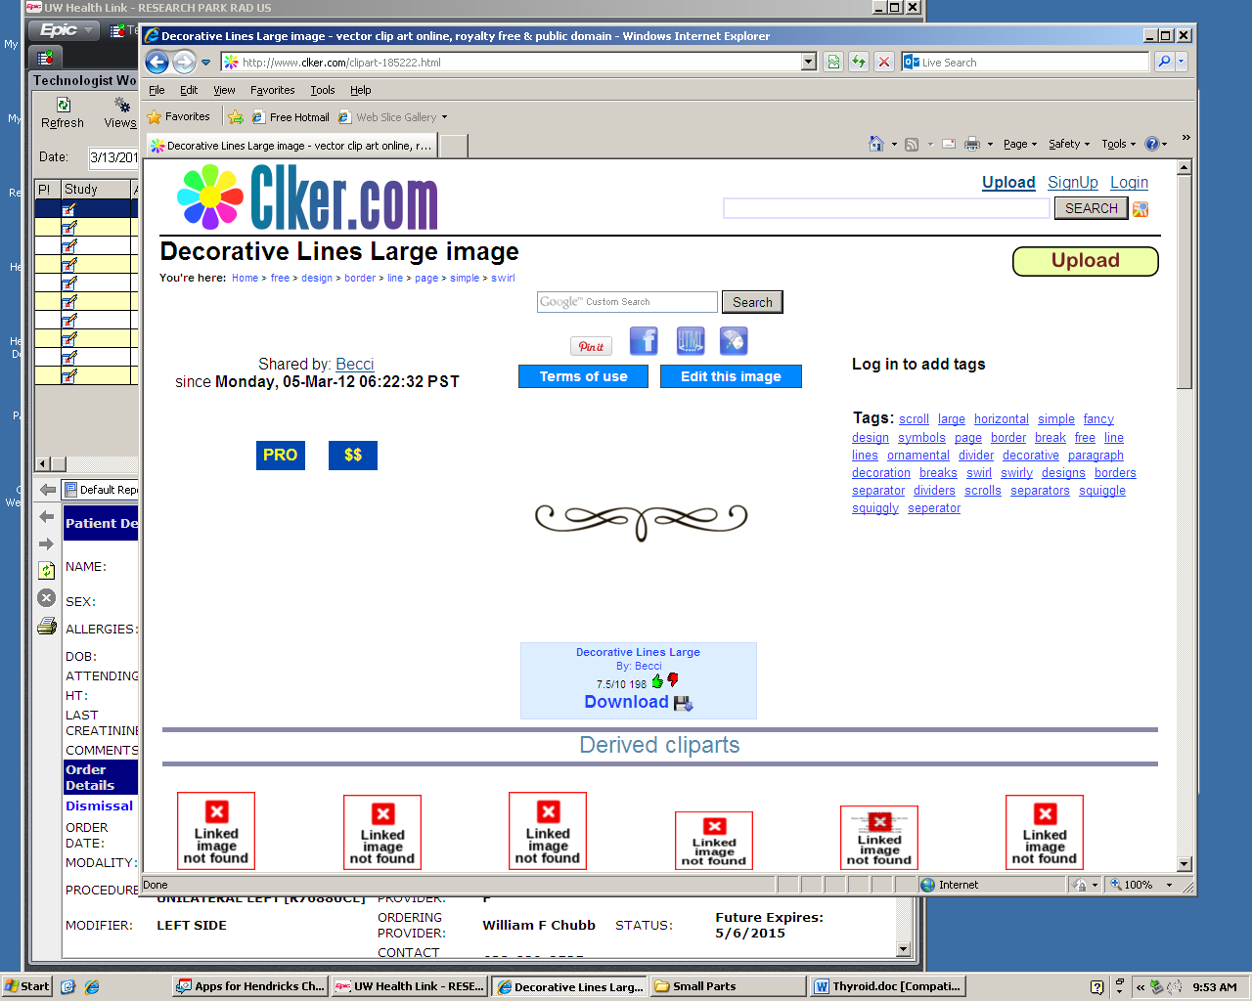

Indications
- Pelvic pain or masses
- Endocrine abnormalities (i.e. PCOS)
- Dysmenorrhea, amenorrhea, abnormal bleeding, or delayed menses
- Evaluation, monitoring, or treatment of infertility
- Limited clinical pelvic exam
- Follow up previous abnormality or characterization of abnormality from other imaging
- Congenital uterine or lower genital tract abnormalities
- Signs/symptoms of pelvic infection
- Excessive bleeding and/or pain after surgery, delivery, or abortion
- Localization of IUD
- Screening for malignancy in high-risk patients
- Evaluation of incontinence or pelvic organ prolapse
- Pre or postoperative evaluation of pelvic structures
- Guidance for interventional or surgical procedures

Equipment
- Curvilinear or sector transducer
  - 2-7 MHz
- Endovaginal transducer
  - 5-9 MHz
Patient Position
- Supine
- Lithotomy
Patient Prep
- Full bladder, if necessary
- Uterine size under 12cm length or provider discretion

Evaluation
Transabdominal & Transvaginal Pelvis
- Uterus
  - Uterine size, shape and orientation
    - Measurements
      - Longitudinal measurement should align with the endometrial lining to cervix, utilizing trace when needed
      - AP measurement must be done on same image as longitudinal measurement, perpendicular to the endometrium
  - Endometrium
    - Measurement
      - Thickest portion, exclude fluid
      - Perpendicular to long axis
    - Thickness, focal abnormalities, echogenicity, fluid/masses within cavity
    - Relationship of masses to endometrium
    - IUD placement
    - Vascular pattern or endometrial abnormalities
      - Power Doppler used if no visible signs of/concern for pregnancy
  - Myometrium
    - Contour, echogenicity, masses, cysts. & symmetry anterior to posterior
  - Cervix
    - Contour, echogenicity, masses, cysts

- Ovaries/Adnexa
  - Ovarian size
    - Abnormalities
  - Location
  - Fallopian tubes, if dilated
  - Adnexal abnormality
    - Relationship to ovary
- Cul-de-sac
  - Presence of fluid or masses
  - Relationship of masses to adjacent anatomy
- Right & Left Flank
  - Longitudinal evaluate for free fluid

Non mobile uterus, fixed retroflexion, or tenderness during ultrasound can occur in the setting of adenomyosis, pelvic adhesion or deep endometriosis in the posterior cul-du-sac

Abnormal ovarian location (posterior cul-du-sac, or adherent to uterus, pelvic side wall, or contralateral ovary) may indicate endometriosis or ovarian torsion

Torsion may appear as asymmetric enlarged ovary, peripheral follicles and/or twisted vessels “whirlpool sign”

Images

Full Protocol
Transabdominal Pelvis (Limited)
- Uterus
- Longitudinal
- Transverse
- Adnexa (Right & Left)
  - Ovaries (if visible)
    - 1 image in either plane
- Right & Left Flank
  - Longitudinal
Transvaginal Pelvis
- Uterus
  - Longitudinal
  - Right to Left (at least 3 images)
  - Midline
      - Measurements (Long, AP)
    - Endometrium (if visible)
      - Measurement (AP)
        - If fluid filled, measure 2 layers separately
  - Cine clip
  - Transverse
  - Cervix to Fundus (at least 3 images)
  - Mid
      - Measurement (Trans)
  - Pathology (Uterus and/or Endometrium)
  - Documents in 3 planes
  - Demonstrate relationship to endometrium (fibroids, polyps, mass, etc.)
  - Color Doppler or Power Doppler
  - Pulsed Wave Doppler
      - Any areas concerning for arteriovenous malformation (AVM)
  - 3D Sweep or manual 3D w/Reconstruction
    - Endometrial mass, congenital abnormalities, thickened and/or heterogenous endometrium, & IUD
- Cul-du-sac
  - Demonstrate cul-du-sac
  - Demonstrate any free fluid or pathology
    - Label free fluid

**Acute pelvic pain is pain that is new, different, or recent

***Abbreviated protocol can be used if recent CT/MR to include PELVIS, w/in 24 hrs for inpatient, outpatient and ER. Include additional images if needed per clinical concern or CT/MR findings.

Transvaginal Pelvis (cont)
- Adnexa/Ovaries if visible (Right & Left)
  - Longitudinal & Transverse
    - Ovary if visible*
      - Measurements (Long, AP, Trans)
      - Cine*
    - Representative adnexa images & cines if ovary not visible
  - Color Doppler (adnexa if ovary not visible)
  - Pathology
    - Documents in 3 planes
    - Color Doppler
    - Cine clip in 1 plane
- Adnexa
  - Visible pathology
    - Document in 3 planes
    - Relationship to ovaries and uterus
- Cervix
  - Longitudinal
  - Transverse
*1 grayscale & 1 cine in BOTH planes OR 2 separate grayscales in BOTH planes & 1 cine EITHER plane
Torsion/Pelvic Pain
- Pulsed Wave Doppler (change order)
  - Arterial and venous signal within each ovary to evaluate for torsion, on patients with enlarged ovary or acute pelvic pain**
  - Cine clip with Color Doppler of ovary, adnexa and vascular pedicle

Abbreviated Protocol***
TV only unless otherwise indicated
- Uterus
  - Longitudinal Cine Clip
    - Measurement (Long, AP)
    - Endometrium measurement (AP)
  - Transverse Cine Clip
    - Measurement (Trans)
  - 3D as indicated
- Adnexa/Ovaries
  - Longitudinal or Transverse Cine Clip
    - Measurements (Long, AP, Trans)
    - Color Doppler
    - Pulsed Wave Doppler, as indicated above (change order)
- Cul-du-sac
- Cervix
- Pathology
  - Document in 3 planes
  - Cine in 1 plane
  - Color Doppler or Power Doppler as needed
Additional Information

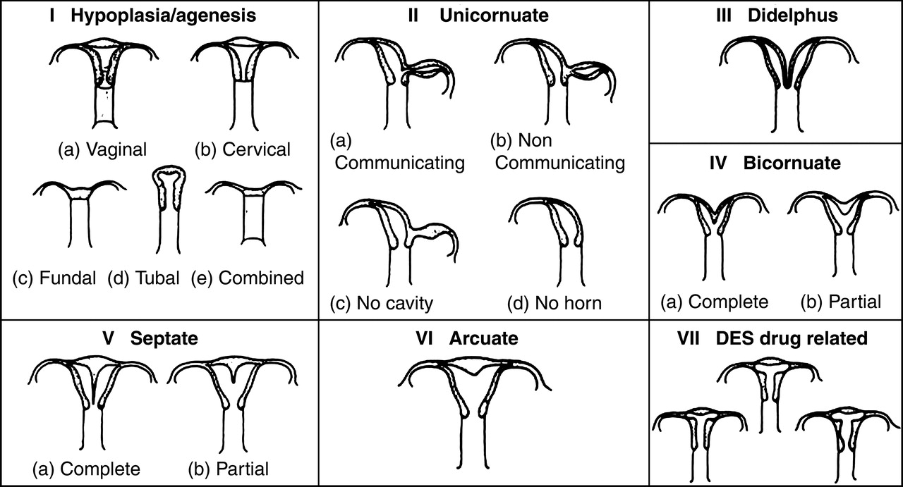
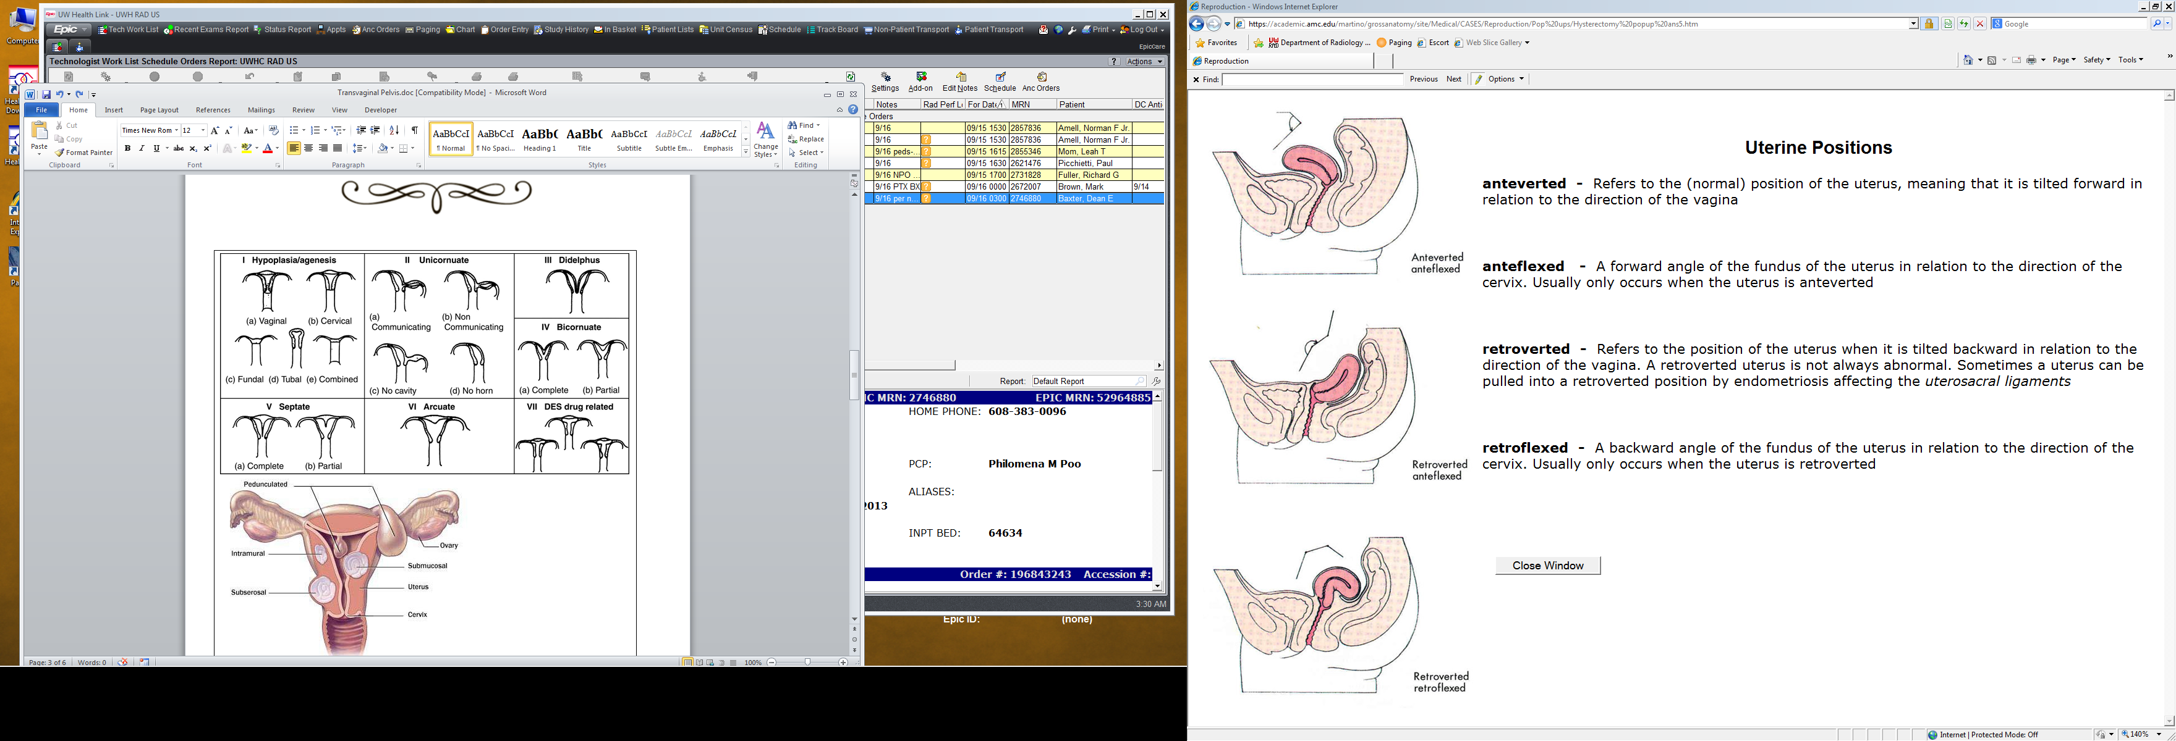

Additional Information

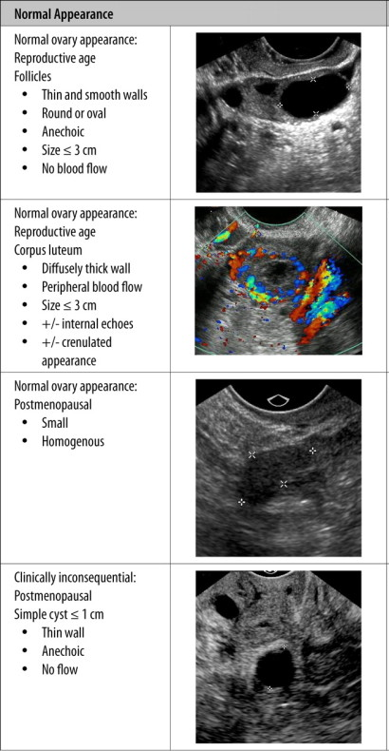
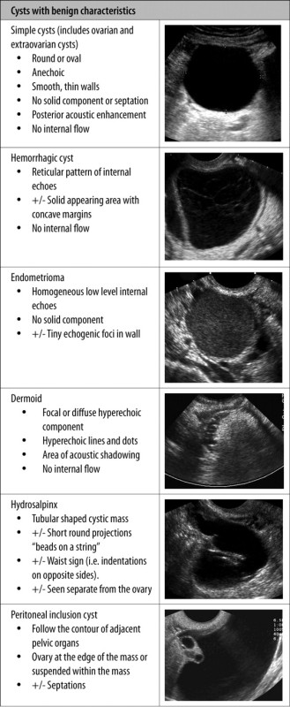

Additional Information

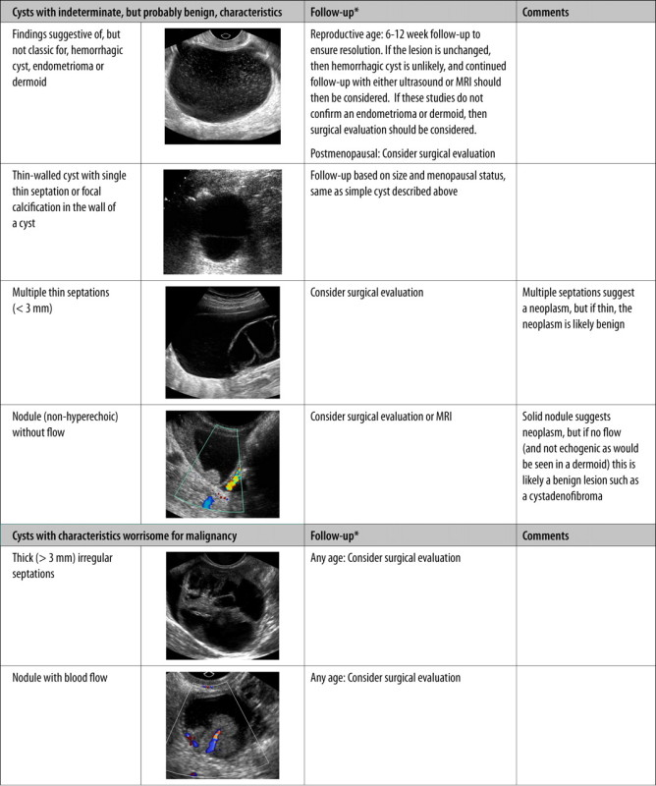
References

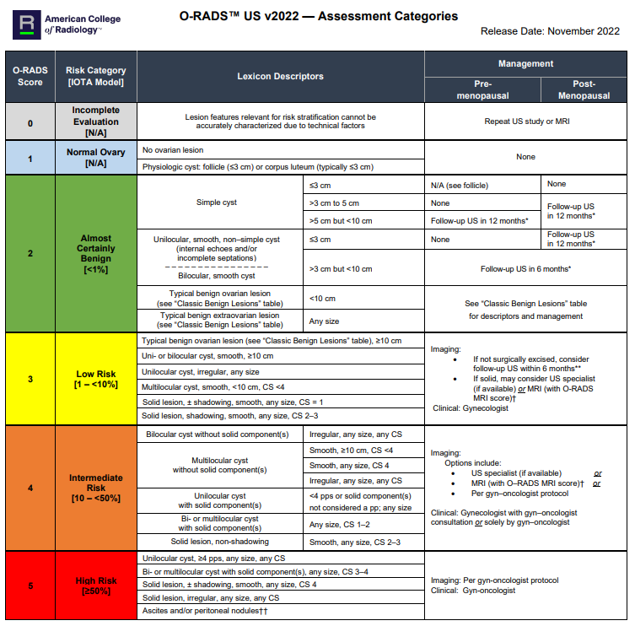

References

- ACR–ACOG–AIUM–SPR–SRU PRACTICE PARAMETER FOR THE PERFORMANCE OF ULTRASOUND OF THE FEMALE PELVIS Rev 2024, Resolution 21
- American College of Radiology. Ultrasound Evaluation Attributes. https://accreditationsupport.acr.org/support/solutions/articles/11000062866-exam-requirements-gynecological-ultrasound-revised-8-23-2024- Updated Aug, 23, 2024. Accessed Apr, 7, 2025.
- https://edge.sitecorecloud.io/americancoldf5f-acrorgf92a-productioncb02-3650/media/ACR/Files/RADS/O-RADS/O-RADS--Ultrasound-v2022-Assessment-Categories.pdf
- http://www.healthmango.com/women/abnormalities-of-uterus/
- http://sedeya.com/Fibroids/fibroid-pictures.html
- http://www.radiologyaz.com/management-of-asymptomatic-ovarian-cysts.html
- https://academic.amc.edu/martino/grossanatomy/site/Medical/CASES/Reproduction/Pop%20ups/Hysterectomy%20popup%20ans5.htm

