Putting preliminary reports into PACS during unexpected downtime

- May occur when there is disruption in the EMR
- When orders are not normally flowing to Powerscribe
- During times when PACS access is not disrupted
- Gives the providers a report to guide treatment during downtime when final reports will not be available in the EMR

From the main tool bar select ‘New Report’. May need to add this from preferences, look for ‘Create Report’ or ‘New Report’

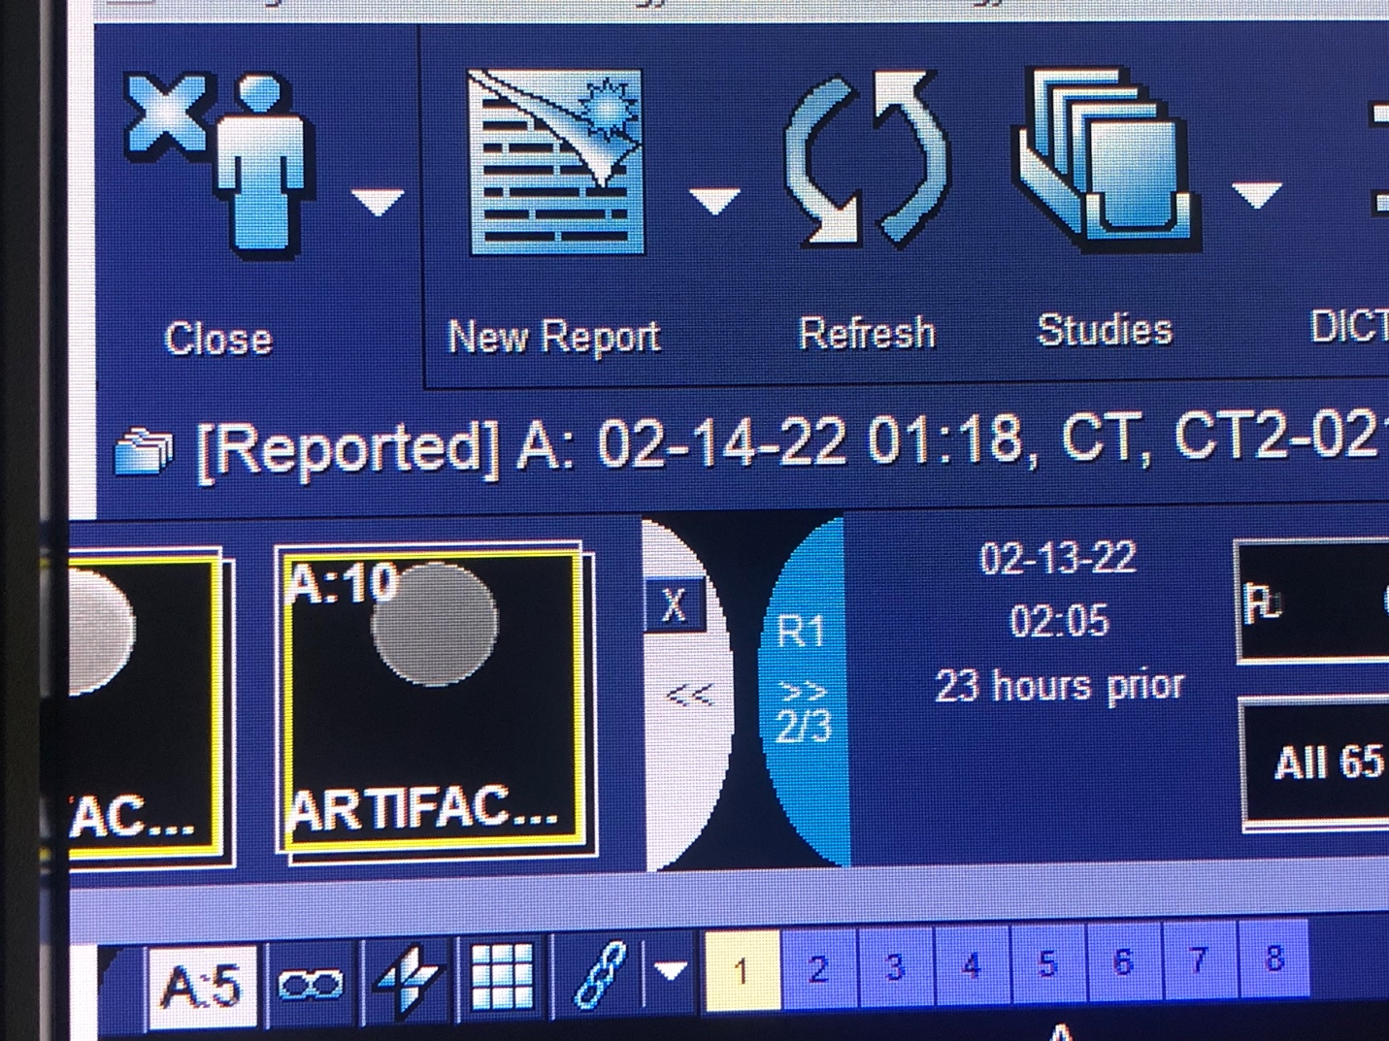

Select ‘Blank Form’

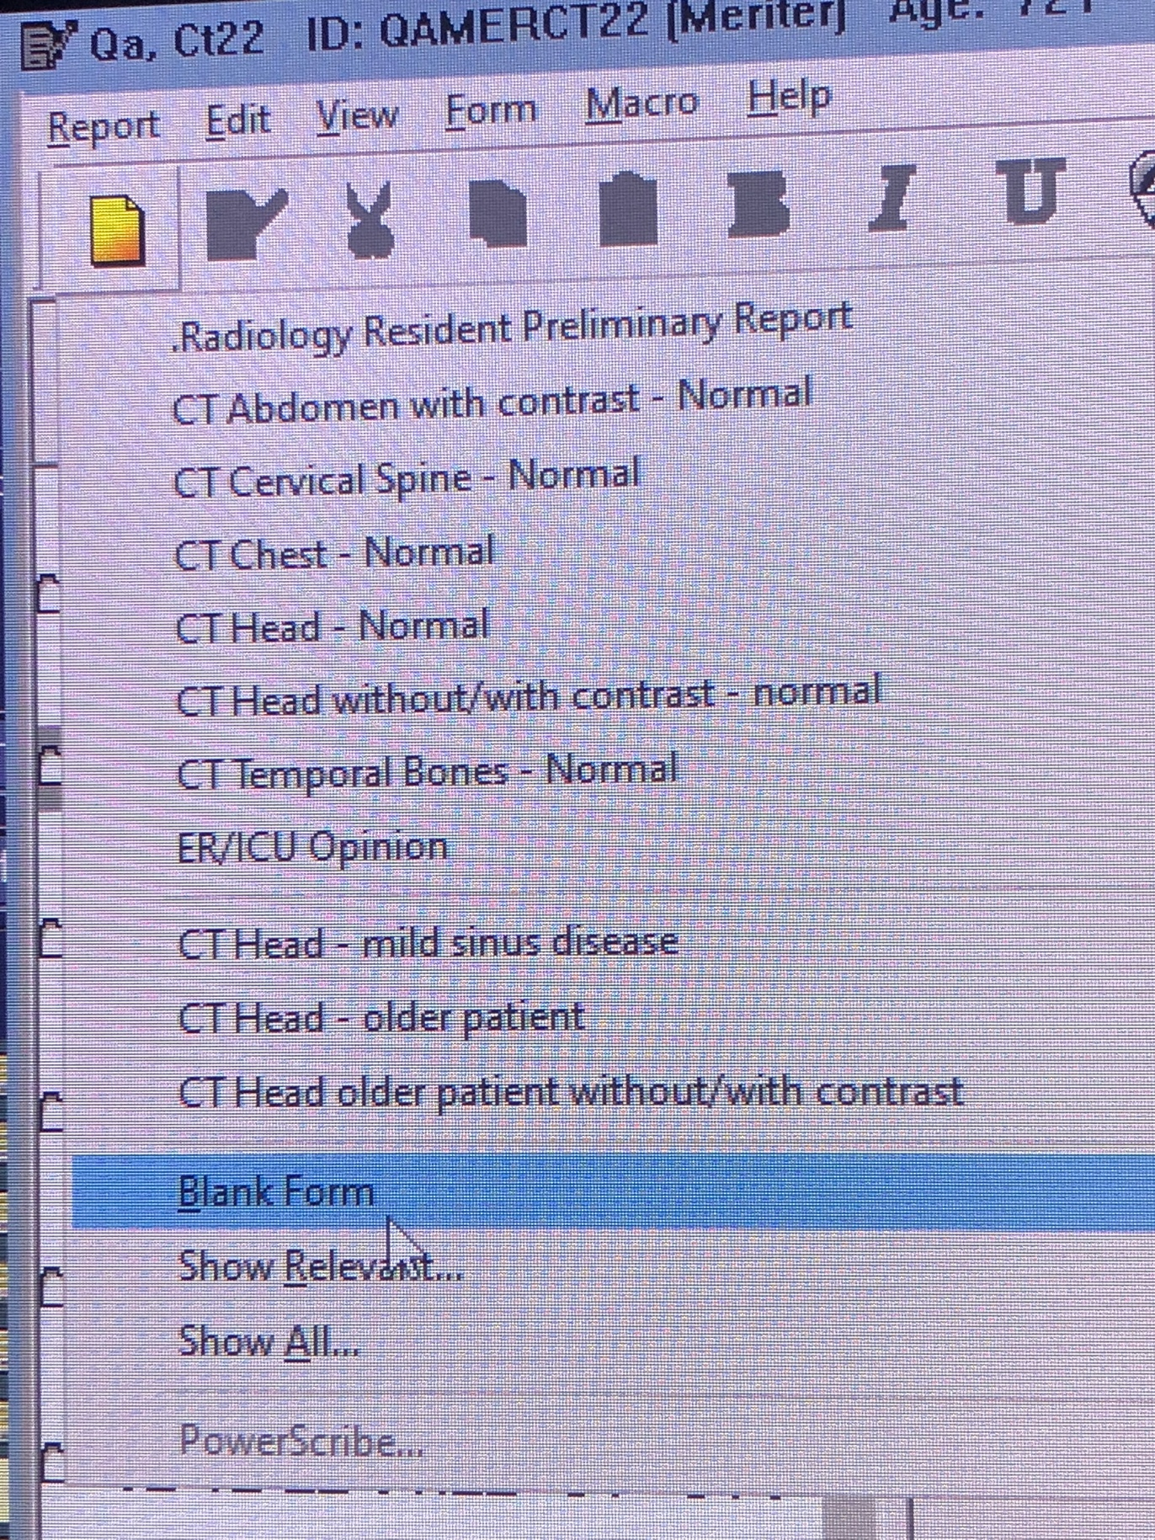
In the window you can type a prelim or if powerscribe is working you can cut and paste from your powerscribe report

At the bottom of the page that pops up, choose ‘Save Preliminary’

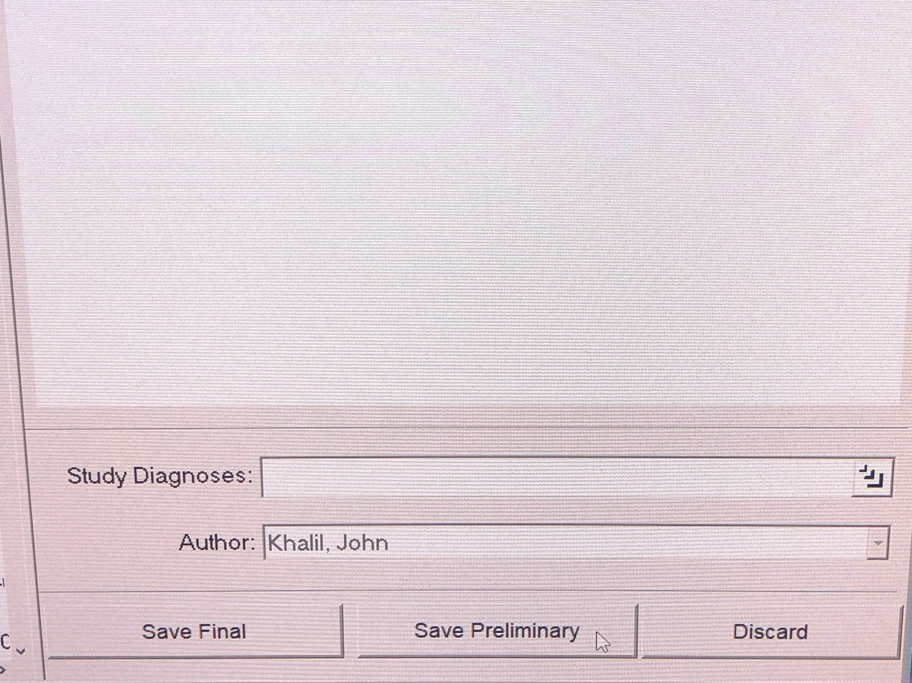

This will save the preliminary report in PACS

Recommend communicating with ER and urgent care providers to let them know to look for the reports in PACS until the EMR issue is resolved

