UWHC Rad Path Correlation in Health Link

Breast Imaging Radiologist on Diagnostics
- Use the (new) Breast Imaging Pathology Dashboard to access all UWHC breast biopsy cases with final pathology result
- Document rad path correlation on new Path Results form
  - Should case be presented at BIP? Update form as follows:
    - Yes – Present at BIP = Yes
    - No – Present at BIP = No
  - Is Rad Path documentation complete? Update form as follows:
    - Yes – Rad Path Documentation Complete? = Yes
    - No – Rad Path Documentation Complete? = No
- Once Rad Path documentation is complete, the breast biopsy study will fall off the rad path worklist and route to the appropriate dashboard section based on the updated status

Breast Imaging Performing/Addending Radiologist
- Use the Breast Imaging Radiologist Dashboard to access your breast biopsy cases with final pathology result
- The dashboard will include breast biopsy cases where BIP conference review is complete AND breast biopsy cases where BIP conference review was not needed
- The breast biopsy case will fall off the Radiologist addendum worklist once the addendum is signed

UWMF Rad Path Correlation in Health Link
- Use the Breast Imaging Radiologist Dashboard to access all 1SP breast biopsy cases with final pathology result
- Evaluate whether breast biopsy case meets criteria for BIP Conference Review
  - If no, complete addendum
  - If yes, close out of Study Review and continue with steps below
- Use the Breast Imaging Pathology Dashboard to access your 1SP biopsy studies with final pathology result
  - Document rad path correlation on new Path Results smartform
  - Update Present at BIP = Yes
- The breast biopsy study will route to the BIP Conference Review section based on the updated recommendation
- Use the Breast Imaging Radiologist Dashboard to access breast biopsy studies once BIP Conference Review complete

BIP Conference Review
- Use the Breast Imaging Pathology Dashboard to access all breast biopsy studies for review at BIP Conference
  - Open each study in Path Results activity to review
  - Once review is complete, update BIP Review Complete = Yes
- Studies will fall off the BIP Conference Review worklist once the recommendation is updated worklist and route to the appropriate dashboard section based on the updated status

UWHC Breast Imaging Diagnostic Radiologist

Use the Breast Imaging Pathology Dashboard to access all UWHC breast biopsy studies with final pathology result
- Open Breast Imaging Pathology Dashboard in Health Link
Note: When opening for the first time you will need to search for the dashboard, like follows:
  - From the Breast Imaging Radiologist Dashboard, click the dashboard arrow and key in Breast Imaging Path
  - Click the Breast Imaging Pathology Dashboard to open
  - The Breast Imaging Pathology Dashboard is shown below
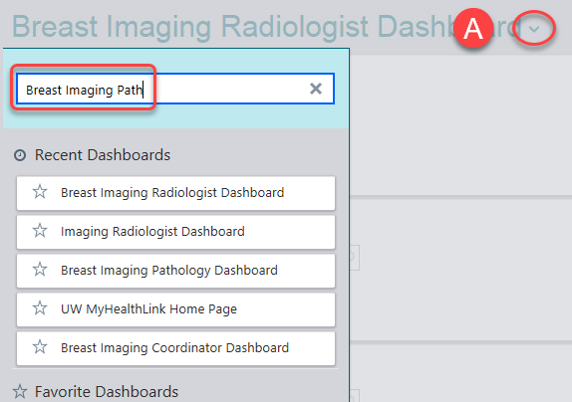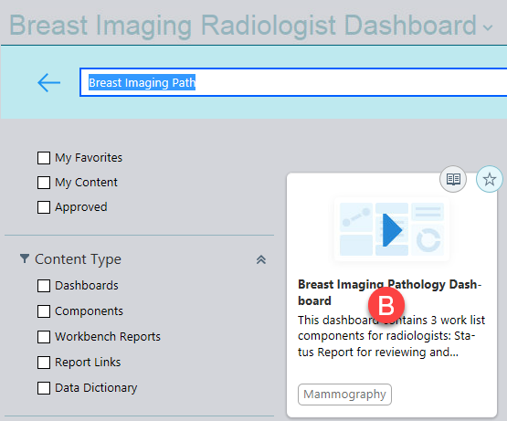
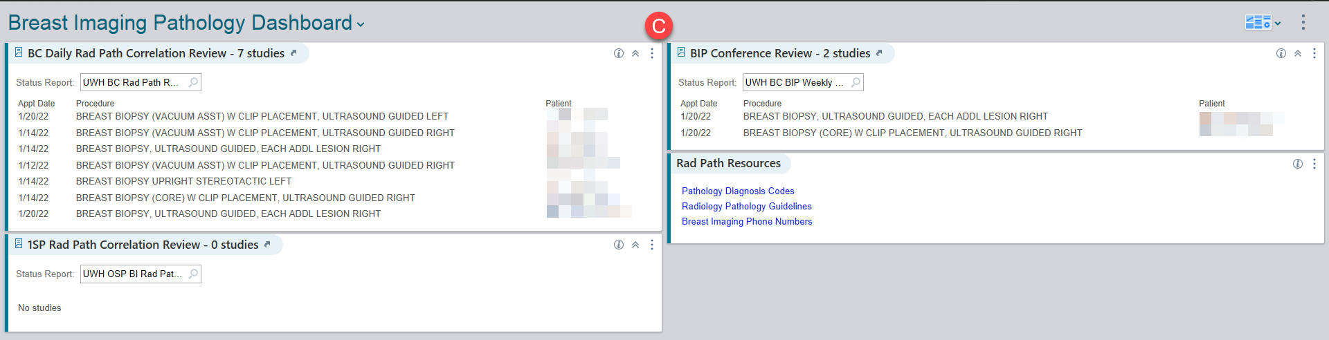
- Click arrow to open BC Daily Rad Path Correlation Review status report
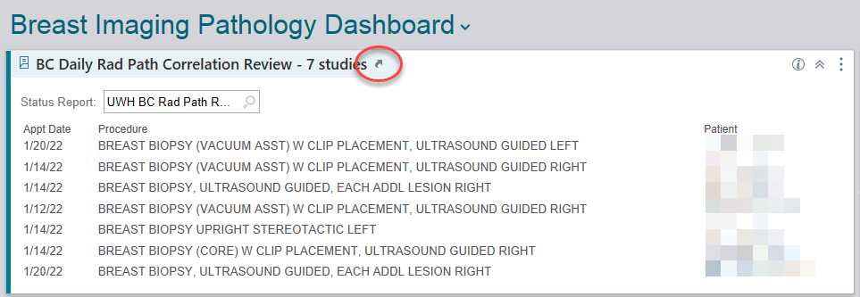
- Highlight patient study by clicking on the row and then click Path Results to open the Rad Path form
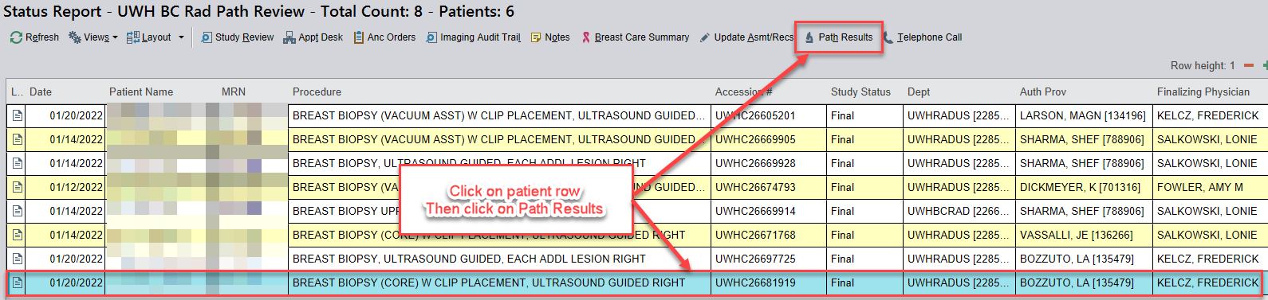
- The Rad Path form opens like below
  - Pathology result displays on the left pane
  - Rad path correlation form displays on the right pane
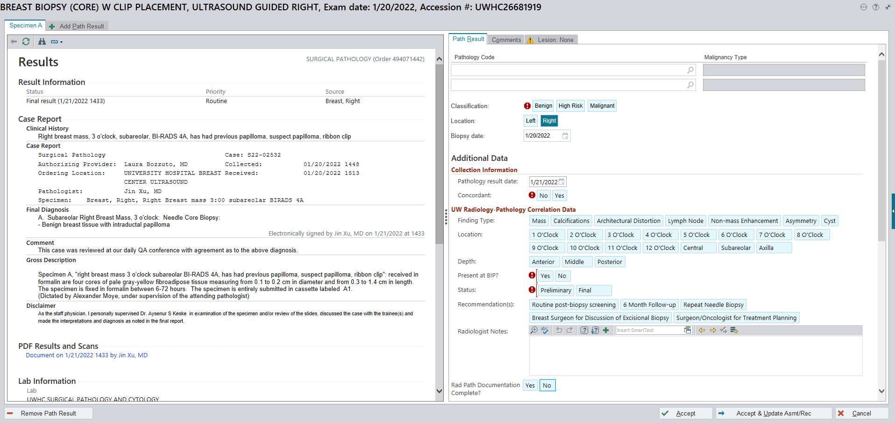
- To optimize and add the biopsy report, click the 3 ellipses on the top right, and select Study Details
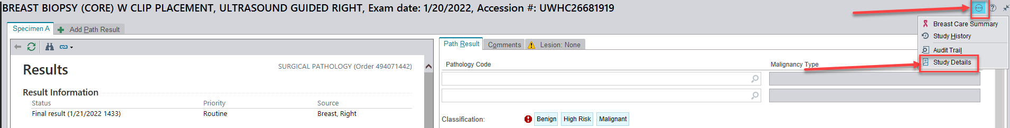
Note: This will default for your current Health Link session, but will need to be done each time you log in to evaluate Rad Path (Epic development has been requested).
- Scroll down in Study Details pane to see biopsy dictation/note
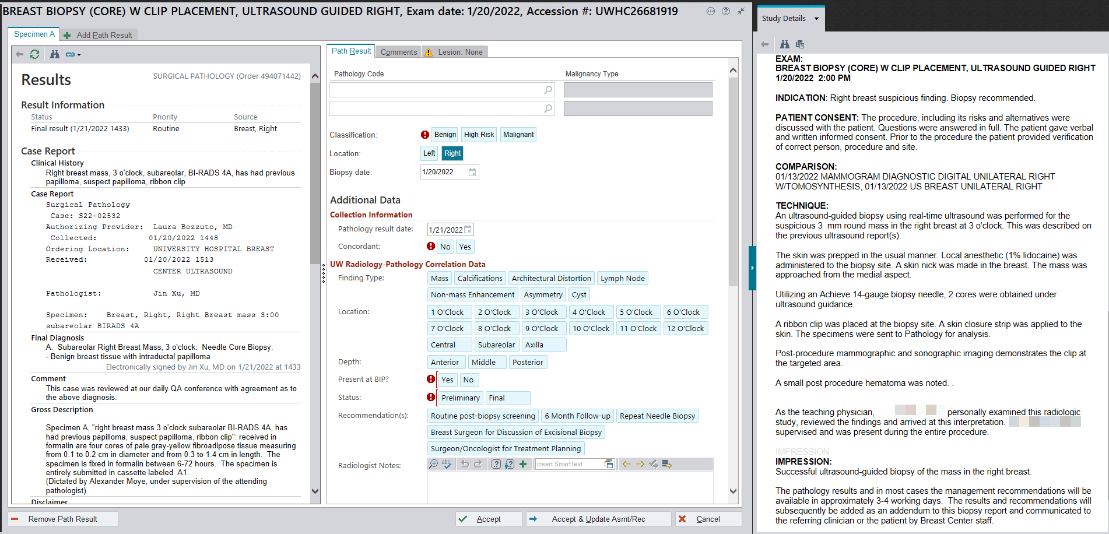

Document rad path correlation when No BIP Conference review needed
- On the Rad Path form, document the following
  - Path type/code (type in the path abbreviation per reference sheet
  - Classification
(Note: This will default once you document the pathology code)
  - Concordance
  - Present at BIP? = No
  - Status = Final
  - Recommendation(s) = ??
  - Radiologist Notes = Add any notes as necessary
  - Rad Path Documentation Complete? = Yes
** Text in red is required for the form to be submitted/saved (classification, concordance, Present at BIP, study recommendation)
- Click Accept
- Study will now appear on the performing Radiologist dashboard for addendum

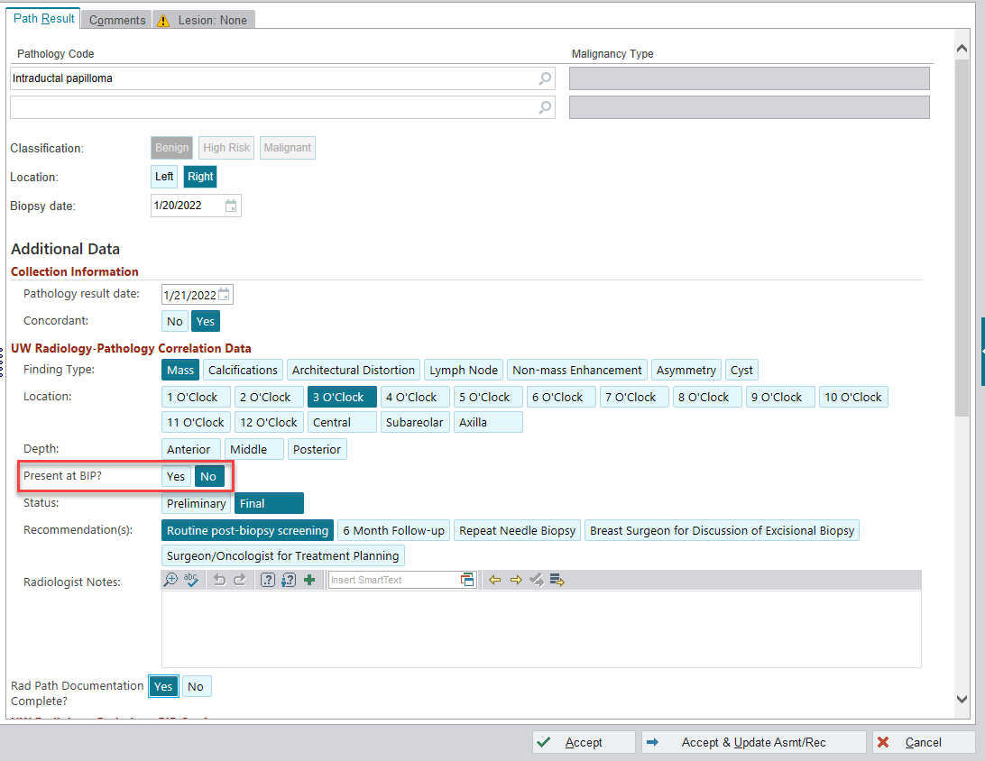

Document rad path correlation when BIP Conference review needed
- On the Rad Path form, document the following:
  - Path type/code (type in the path abbreviation per reference sheet
  - Classification
(Note: This will default once you document the pathology code)
  - Concordance
  - Present at BIP? = Yes
  - Status = Preliminary or Final
  - Recommendation(s) = ??
  - Radiologist Notes = Add any notes as necessary
  - Rad Path Documentation Complete? = Yes
- Click Accept
- The study will now appear on the Radiology Pathology dashboard for BIP Conference Review
(Note: Preliminary Status will only show on BIP Conference Review work list, while Final Status will show on both BIP Conference Review work list and performing Radiologist dashboard for addendum)
** Text in red is required for the form to be submitted/saved (classification, concordance, Present at BIP, study recommendation)
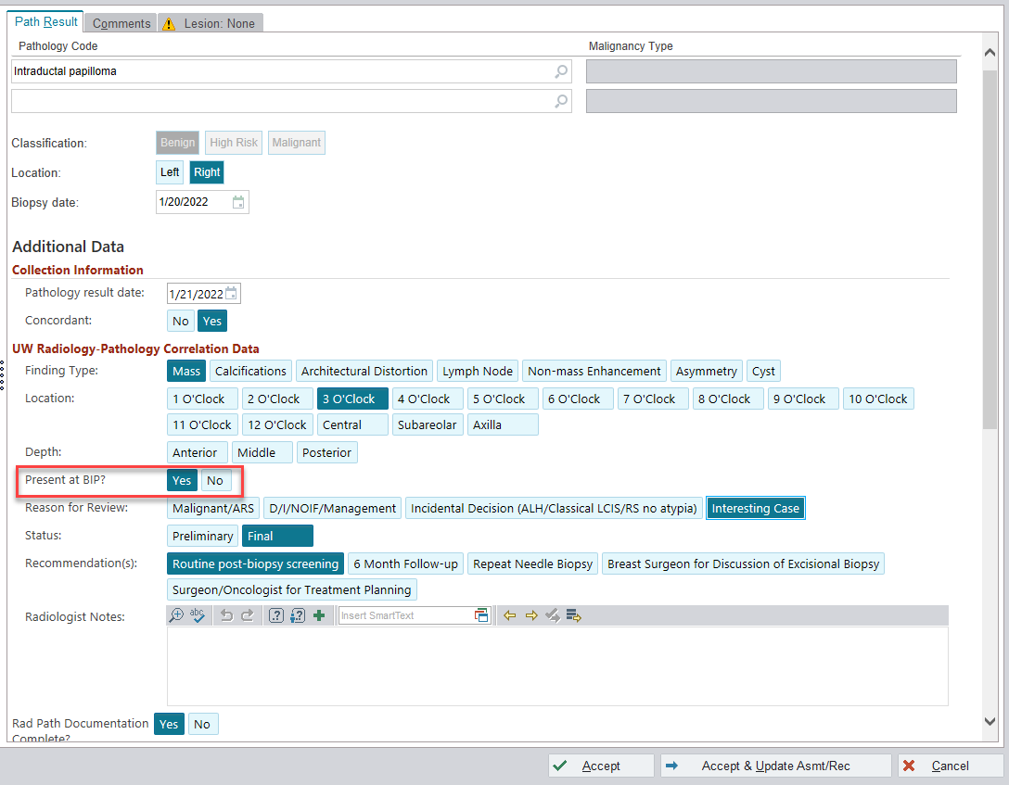

UWHC Breast Imaging Diagnostic Radiology Fellow

Use the Breast Imaging Pathology Dashboard to access all UWHC breast biopsy studies with final pathology result
- Open Breast Imaging Pathology Dashboard in Health Link
Note: When opening for the first time you will need to search for the dashboard, like follows:
  - From the Breast Imaging Radiologist Dashboard, click the dashboard arrow and key in Breast Imaging Path
  - Click the Breast Imaging Pathology Dashboard to open
  - The Breast Imaging Pathology Dashboard is shown below
- Click arrow to open BC Daily Rad Path Correlation Review status report
- Highlight patient study by clicking on the row and then click Path Results to open the Rad Path form
- The Rad Path form opens like below
  - Pathology result displays on the left pane
  - Rad path correlation form displays on the right pane
- To optimize and add the biopsy report, click the 3 ellipses on the top right, and select Study Details
Note: This will default for your current Health Link session, but will need to be done each time you log in to evaluate Rad Path (Epic development has been requested).
- Scroll down in Study Details pane to see biopsy dictation/note

Document rad path correlation when both BIP Conference review needed and
No BIP Conference review needed (Radiology Fellows)
- On the Rad Path form, document the following:
  - Path type/code (type in the path abbreviation per reference sheet
  - Classification
(Note: This will default once you document the pathology code)
  - Concordance
  - Present at BIP? = Yes
  - Status = Preliminary or Final
  - Recommendation(s) = ??
  - Radiologist Notes = Add any notes as necessary
  - Rad Path Documentation Complete? = No
- Click Accept
- The study will remain on the BC Daily Rad Path Correlation Review status report awaiting review by the Attending Radiologist (Note: Once the Attending Radiologist updates Rad Path Documentation Complete? = Yes, study will no longer display on BC Daily Rad Path Correlation Review status report)
** Text in red is required for the form to be submitted/saved (classification, concordance, Present at BIP, study recommendation)
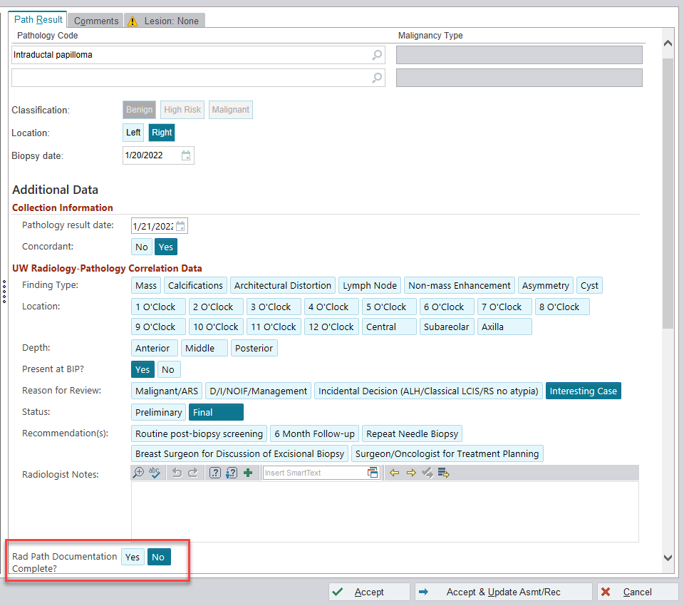

UWHC Breast Imaging Performing/Addending Radiologist

Use the Breast Imaging Radiologist Dashboard to access your breast biopsy studies with final pathology result and BIP Conference review complete (or not needed)
- Open Breast Imaging Radiologist Dashboard in Health Link
- Click arrow to open My Breast Biopsies for Addendum status report
- Highlight patient study
- Review BIP Conference recommendation and notes (if applicable)
- Click Study Review button
- Click Addendum
- Complete addendum dictation using the Rad Path macro buttons
- Sign the addendum
- The study will now fall off the Breast Biopsies for Addendum status report, and the final addendum will be sent to the ordering provider and to the patient’s MyChart account (if applicable)

UWMF Breast Imaging Radiologist

Use the Breast Imaging Radiologist Dashboard to access your breast biopsy studies with final pathology result
- Open Breast Imaging Radiologist Dashboard in Health Link
- Click on your biopsy study to review final pathology result in Study Review activity
- Should study be reviewed at BIP Conference?
  - If No, do not review at BIP Conference:
    - Click Addendum
    - Complete addendum dictation using the Rad Path macro buttons
    - Sign the addendum
  - If Yes, review at BIP Conference
    - Close the study without saving
    - Continue below

Use the Breast Imaging Pathology Dashboard to document rad path correlation and recommend a breast biopsy for BIP Conference review
- Open Breast Imaging Pathology Dashboard in Health Link
Note: When opening for the first time you will need to search for the dashboard, as follows:
  - From the Breast Imaging Radiologist Dashboard, click the dashboard arrow and key in Breast Imaging Path
  - Click the Breast Imaging Pathology Dashboard to open
  - The Breast Imaging Pathology Dashboard is shown below
- Click arrow to open 1SP Rad Path Correlation Review

- Highlight patient study by clicking on the row and then click Path Results to open the Rad Path form
- The Rad Path form opens
  - Pathology result displays on the left pane
  - Rad path correlation form displays on the right pane
- To optimize and add the biopsy report, click the 3 ellipses on the top right, and select Study Details
Note: This will default for your current Health Link session, but will need to be done each time you log in to document Rad Path and BIP Review (Epic development has been requested).
- Scroll down in Study Details pane to see biopsy dictation/note

- On the Rad Path form, document the following:
  - Path type/code (type in the path abbreviation per reference sheet
  - Classification
(Note: This will default once you document the pathology code)
  - Concordance
  - Present at BIP? = Yes
  - Status = Preliminary or Final
  - Recommendation(s) = ??
  - Radiologist Notes = Add any notes as necessary
  - Rad Path Documentation Complete? = Yes
- Click Accept
- The study will now appear on the Radiology Pathology dashboard for BIP Conference Review
(Note: Preliminary Status will only show on BIP Conference Review work list, while Final Status will show on both BIP Conference Review work list and performing Radiologist dashboard for addendum)
** Text in red is required for the form to be submitted/saved (classification, concordance, Present at BIP, study recommendation)

UWMF Breast Imaging Radiologist

Use the Breast Imaging Radiologist Dashboard to access your breast biopsy studies with final pathology result and BIP Conference review complete (or not needed)
- Open Breast Imaging Radiologist Dashboard in Health Link
- Click arrow to open My Breast Biopsies for Addendum status report
- Highlight patient study
- Review BIP Conference recommendation and notes
- Click Study Review button
- Click Addendum
- Complete addendum dictation using the Rad Path macro buttons
- Sign the addendum
- The study will now fall off the Breast Biopsies for Addendum status report, and the final addendum will be sent to the ordering provider and to the patient’s MyChart account (if applicable)

